stock price crash risk may be defined as the likelihood a stock has of suffering a price crash, i.e., “the likelihood of observing extreme negative values in the distribution of firm-specific returns”.

Previous literature on the topic already defined several proxies for assessing stock price crash risk. defines two different measures of crash propensity:

**NCSKEW and Down To Up Volatility.**

NCSKEW,which stands for “negative coefficient of skewness”,

allows us to compare the shape of the left (negative) tail of the distribution of returns to the shape of the right (positive) one and thus conclude that higher values of this indicator result in a longer left tail meaning that the stock is more prone to crash than another one with smaller left tail.

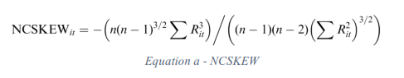

DUVOL (meaning “down-to-up volatility”) compares the magnitude of the returns below the period’s mean return to the magnitude of the returns above the mean return. It classifies these periods as “down” periods if their return in below the period average return and “up” periods if they are above. Once again, higher values on this indicator represent a more left-skewed distribution and thus, higher crash possibility.

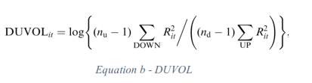

CRASH a binary variable (Dummy Variable) which takes the value 1 if, in that week, the return is 3.09 standard deviations below the yearly mean return and 0 if it is above that threshold. The **3.09** value regarding standard deviations is chosen in order to include the 0.1% of returns in each tail of an assumed normal distribution of that firm-stock returns meaning that, any observation included in those 0.1% are considered extreme events (whether a crash or a jump depending on which side it is located). Also with this variable, a higher value represents a higher crash frequency in the returns distribution.

**1--Stock Price Crash Determinants:**

The main goal of crash risk literature is trying to understand which factors influence stock price crashes. These factors can be grouped in distinct segments such as i) capital market related factors, ii) company related factors, iii) management related factors and iv) other factors.

Besides these previous major groups, there are other factors that are believed to influence stock price crash likelihood. Religion is appointed as a predictor for stock price crash. conclude that companies with headquarters located in counties with higher levels of religiosity present lower crash risk. Also, companies with institutional investors which have a stable presence in the company while conducting a monitoring role, have lower stock price crash risk. Companies where insiders have a higher proportion of ownership also tend to have lower future crashes.

We start our analysis by calculating the stock Price crash risk; in our data we have 10 country (Bahrain, Egypt, Jordan, Lebanon, Oman, Qatar, Saudi Arabia, Tunisia, United Arab Emirates, Morocco).

By Using Stata we calculate the return of stock for each country (variable “id” in the dataset) and by date (variable “date2”). We used the formula of the return of the **Price** (variable “Price ” the dataset). Fore more details (see, Crash Risk.do file)

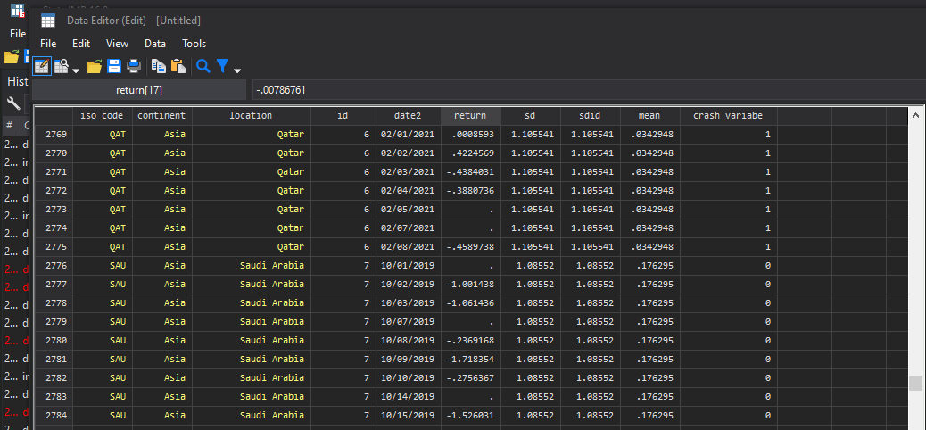

The result of the crash analysis sorted by (country and date)

The crash variable is measured as: An indicator variable that equals one if a stock experiences one or more stocks a returns exceeding 3.09 standard deviations below the mean stock a returns over the fiscal year and zero otherwise, with 3.09 chosen to generate frequencies of 0.1% in a normal distribution.

As you see in the capture Qatar had 1 as crash binary number (crash_variable) because it had the return below the yearly mean return of 3.09 standard deviations and 0 for Saudi Arabia.

**2--Negative Coefficient of Skewness (NCSKEW):**

To calculate NCSKEW we need a market index for each country, we calculate the market index index using volume (vol) of transaction for each country and by calculating the return of the market index (market_index). For more details (see, SKEWNESS.do file).

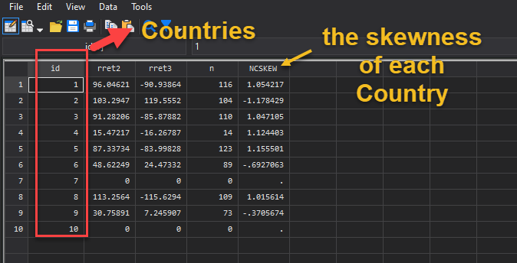

As you see the output we have the **NCSKEW** for each country.

**3--Stock Price Crash risk using down-to-up volatility (DUVOL):**

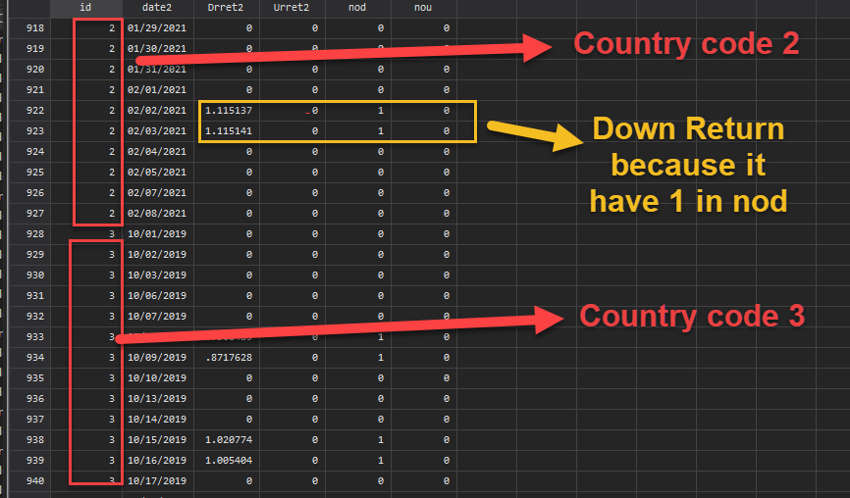

As you the in image for each period there is up and down return, when the return is above the annual mean the country has up return.

And if we want to see if a country made an Up or Down for the entire period of observation we can sort the analysis in stata by country. As you see in image the result according to each country.

